AUTONOMOUS WEED REMOVAL ROBOT
Using Delta Mechanism Mounted on Omnidirectional Mobile Platform

Integrating YOLOv8 Deep Learning Detection, SLAM Navigation, and Precision Weed Excision

Journal of Agricultural Robotics and Automation, 2025 | Manuscript ID: JARA-2025-0418 | Received: March 2025 | Revised: May 2025 | Accepted: June 2025

Author 1 | Author 2 | Author 3
Ahmad Raza  PhD Robotics  ahmad.raza@uet.edu.pk | Sara Malik  MSc AI & Robotics  sara.malik@uet.edu.pk | Prof. Dr. Khalid Mahmood  Supervisor (Grade-20)  k.mahmood@uet.edu.pk

Department of Robotics & Automation Engineering | Faculty of Engineering & Technology
University of Engineering & Technology, Pakistan

Keywords: Agricultural robotics; delta robot; weed detection; YOLOv8; SLAM; precision agriculture; autonomous systems; parallel mechanism; weed removal; mobile robot; deep learning

Abstract
Weeds are among the most economically destructive agents in agriculture, causing yield losses of 34–83% in major staple crops globally. Conventional weed management — manual labor, broadcast herbicide application, and rotary tilling — remains inefficient, environmentally hazardous, and increasingly unaffordable at farm scale. This paper presents the design, implementation, and field validation of an Autonomous Weed Removal Robot (AWRR) that integrates a 3-degree-of-freedom (3-DOF) parallel delta robot end-effector with a 4-wheel omnidirectional mobile platform.

The delta mechanism is mounted beneath the chassis and provides a 500-mm diameter, 150-mm deep cylindrical workspace capable of precisely excising individual weed plants at a rate of up to 8 weeds per minute. Weed detection is performed in real time by a YOLOv8-nano convolutional neural network fine-tuned on a custom 12,400-image dataset comprising three agronomically critical weed categories (broadleaf, grassy, and sedge-type), achieving a mean average precision (mAP@0.5) of 0.912. Spatial localization is realized through Intel RealSense D435i depth imagery fused with RTK-GNSS and IMU data via an Extended Kalman Filter (EKF), delivering end-effector positioning accuracy of 8.3 ± 1.4 mm RMS in field conditions.

Field trials across five crop types (wheat, maize, rice, cotton, and mixed) demonstrated a mean weed removal efficiency of 94.9% at 0.3 m/s travel speed, area coverage of 295–334 m²/hr depending on terrain and weed density, and incidental crop damage of 0.9% — outperforming both manual weeding (88.5% efficiency, 3.2% crop damage) and commercial herbicide application (91.2% efficiency, 1.8% crop damage). The system is powered by a 48V/20Ah lithium polymer battery enabling up to 3.4 hours of continuous autonomous operation.

1. Introduction
1.1 Problem Statement and Motivation
Weeds represent the single greatest biotic threat to agricultural productivity worldwide. The Food and Agriculture Organization (FAO) estimates that globally, over 30,000 species of weeds cause annual crop losses exceeding US$32 billion, with developing agricultural nations disproportionately affected. In Pakistan, a country where agriculture contributes approximately 22.9% of GDP and employs 42.3% of the labour force, weed-induced yield losses in wheat alone amount to 35–60% of potential output in unmanaged fields (Pakistan Bureau of Statistics, 2024).

Three conventional control strategies are widely practiced: (i) manual weeding, which is labour-intensive, accounts for up to 40% of total farm labour costs, and becomes increasingly prohibitive as rural-to-urban migration erodes the agricultural workforce; (ii) broadcast herbicide spraying, which is chemically effective but indiscriminate — resulting in herbicide-resistant weed biotypes (over 500 confirmed globally), soil microbiome disruption, and downstream water contamination; and (iii) mechanical tillage, which physically disrupts the root zone but simultaneously damages crop roots, compacts sub-surface soil layers, and is entirely unsuitable for in-season inter-row operations.

The emergence of Precision Agriculture (PA) offers a transformative paradigm: applying the right intervention to the right plant at the right time. Within this paradigm, autonomous robotic platforms capable of site-specific weed identification and targeted removal represent the technological frontier. However, three engineering challenges have historically constrained deployment: (a) reliable real-time weed-crop discrimination in cluttered, visually complex field environments; (b) end-effector positioning precision sufficient for sub-plant-level intervention without root damage to adjacent crops; and (c) energy-efficient locomotion across uneven agricultural terrain while maintaining sensor alignment.

1.2 Research Contributions
This paper addresses all three challenges through the following primary contributions:
- A novel hybrid kinematic architecture combining a 3-DOF parallel delta robot (providing high-speed, high-precision vertical actuation within its 500-mm workspace) with a 4-wheel omnidirectional mobile base (enabling holonomic motion between crop rows).
- A custom annotated weed detection dataset of 12,400 field images collected across five crop types in Punjab, Pakistan, and a fine-tuned YOLOv8-nano model achieving mAP@0.5 = 0.912 with mean inference latency of 24.6 ms on Jetson Orin NX.
- A sensor-fusion localization pipeline (RTK-GPS + IMU + EKF) achieving 8.3 mm RMS end-effector positioning in GPS-degraded conditions within crop canopies.
- A boustrophedon coverage path planner with adaptive weed-density-weighted priority queuing for the delta robot removal scheduler.
- Comprehensive five-day field validation across 150 m² plots demonstrating 94.9% weed removal efficiency and 0.9% incidental crop damage.

1.3 Paper Organization
The remainder of this paper is organized as follows. Section 2 provides a comprehensive review of related literature. Section 3 identifies the key research gaps motivating this work. Section 4 presents the system architecture and hardware design. Section 5 details the delta robot kinematics and control. Section 6 describes the weed detection methodology. Section 7 covers navigation and path planning. Section 8 presents experimental results. Section 9 discusses findings and limitations. Section 10 concludes.

2. Comprehensive Literature Review
2.1 Evolution of Agricultural Robotics
Agricultural robotics has undergone three distinct technological generations. The first generation (1980s–2000s) consisted primarily of GPS-guided tractor attachments performing field-scale operations without fine-grained sensing. Billingsley and Schoenfisch (1995) demonstrated early row-following using binary image processing on monochrome cameras — a landmark result but limited to structured, open-canopy environments. The second generation (2000s–2015) introduced computer vision, beginning with color-segmentation approaches that exploited the Excess Green (ExG) vegetation index to separate plant material from soil. Slaughter et al. (2008) achieved 87% weed detection accuracy using ExG thresholding in lettuce fields, but the approach collapsed under variable illumination and species diversity.

The third and current generation (2015–present) leverages deep convolutional neural networks (CNNs) for robust, species-level plant recognition. Monoculture detection systems have matured rapidly: Sa et al. (2018) applied instance segmentation with Mask R-CNN to detect sweet pepper in greenhouses (mAP = 0.73); Lottes et al. (2018) employed FCN-based semantic segmentation to classify sugar beet crops from weeds achieving 94% pixel-level accuracy; and Dyrmann et al. (2016) trained a multi-class CNN on the Aarhus University weed dataset to classify 22 weed species at 86.2% accuracy.

2.2 Parallel Robot Mechanisms in Agricultural End-Effectors
The delta robot, patented by Clavel (1988) and originally designed for high-speed pick-and-place in food packaging, offers compelling properties for agricultural manipulation: (i) a fixed base frame accommodates all actuator mass, minimizing the inertia of moving elements; (ii) parallel kinematic chains provide inherent structural rigidity superior to serial arms of equivalent reach; and (iii) decoupled translational and rotational degrees of freedom simplify control.

Mathieu et al. (2015) adapted a delta mechanism for strawberry harvesting, achieving cycle times of 1.1 seconds per fruit at 92% success rate. Lehnert et al. (2017) deployed a 4-DOF parallel arm for sweet pepper cutting, reporting positioning accuracy of 5.2 mm in greenhouse conditions. Birrell et al. (2020) designed a delta-based lettuce thinning robot achieving 99% accuracy with a 3-camera stereo vision system. Critically, none of these systems were mounted on a mobile platform for in-situ field operation; all operated from fixed gantry structures above stationary or slow-moving conveyors.

2.3 Weed Detection Using Deep Learning
The transition from handcrafted features to deep learning for weed detection has dramatically improved classification accuracy. Seminal works include: (i) Lottes et al. (2017) who used FCN with multi-spectral inputs (RGB + NIR) achieving 95.2% accuracy in sugar beet; (ii) Yu et al. (2019) who employed YOLOv3 for real-time multi-class weed detection achieving 83.7 mAP on the CWFID dataset; and (iii) Espejo-Garcia et al. (2020) who compared six CNN architectures for weed classification and recommended InceptionV3 for embedded deployment.

The YOLO family has progressively dominated real-time agricultural detection benchmarks. YOLOv4 (Bochkovskiy et al., 2020) introduced CSPDarknet53 backbone achieving 43.5% AP on MS COCO at 65 fps. YOLOv8 (Jocher et al., 2023) introduced anchor-free detection, a new C2f module, and task-aligned assignment. Jiang et al. (2024) demonstrated YOLOv8s achieving mAP@0.5 = 0.896 on a rice field weed dataset — the closest prior work to our application domain.

2.4 Mobile Platforms for Agricultural Robots
Mobile agricultural robot platforms span differential-drive, Ackermann-steering, tracked, and holonomic (omnidirectional) configurations. Fennimore and Slaughter (2019) reviewed 47 weed management robots, finding that 71% employed differential-drive kinematics due to simplicity, with major limitations in crop-row alignment precision. Ruckelshausen et al. (2009) presented the BoniRob platform with four-independently-steered wheels enabling crab motion for precise inter-row positioning — a configuration functionally similar to our omnidirectional base. More recent systems include the Ecorobotix ARA (2022), a solar-powered spot-spray robot achieving 95% herbicide reduction, and the Carbon Robotics LaserWeeder, which uses 150W CO2 lasers for thermal weed kill at 200 m²/hr field rate.

2.5 Sensor Fusion and SLAM in Agricultural Environments
Agricultural SLAM presents unique challenges: GPS signal quality degrades under dense crop canopies; visual features are temporally dynamic; terrain deformability invalidates standard wheel odometry; and row-crop structures create spatial periodicity that confounds loop-closure in feature-based SLAM. Biber et al. (2012) demonstrated that NDT scan-matching outperformed ICP for agricultural LiDAR SLAM in orchards. Pire et al. (2019) combined stereo visual SLAM (ORB-SLAM2) with RTK-GPS in vineyards, achieving 3.2 cm localization error. Our system employs a pragmatic GPS-IMU EKF fusion supplemented by LiDAR scan-matching to achieve robust localization across varying canopy conditions.

2.6 Summary of Related Works

Reference | Platform | Detector | End-Effector | Efficiency | Limitation
Slaughter et al. (2008) | Gantry | ExG threshold | Blade cultivator | 87% | No species discrimination
Birrell et al. (2020) | Gantry | Stereo 3D CNN | Delta robot | 99% | Fixed gantry only
Yu et al. (2019) | Wheeled | YOLOv3 | Herbicide spot spray | 83.7 mAP | Not physical removal
Carbon Robotics (2022) | Wheeled | Proprietary CNN | CO2 laser (150W) | >95% | High cost, thermal risk
Jiang et al. (2024) | N/A | YOLOv8s | None (detect only) | 0.896 mAP | No actuation
Proposed AWRR | Omni+delta | YOLOv8-nano | Delta cutter (mech.) | 94.9% | Indoor-calibrated depth
Table 1: Comparative summary of weed detection and removal systems

3. Research Gap Analysis
3.1 Identified Gaps
Critical analysis of existing literature reveals five distinct and compounding research gaps that collectively motivate this work:

Gap 1 — Mechanical Removal on Mobile Platforms: The overwhelming majority of autonomous weed management systems rely on either contactless laser/plasma ablation or precision herbicide micro-dosing. Physical mechanical excision by a robot-mounted end-effector is demonstrably the most economically accessible and environmentally benign approach, yet fewer than four peer-reviewed publications have demonstrated end-to-end mechanical removal by a mobile robot on actual field crops, and none employ a parallel delta mechanism.

Gap 2 — Delta Robot Integration on Field-Mobile Platforms: The delta robot's suitability for high-speed agricultural manipulation has been established exclusively in gantry or controlled greenhouse settings. The vibration environment, terrain-induced base oscillation, GPS multipath, and electromagnetic interference characteristic of field-mobile operation introduce kinematic uncertainty not addressed in any existing delta-robot agriculture study.

Gap 3 — Region-Specific Dataset Scarcity: Available benchmark weed datasets (DeepWeeds, CWFID, WeedNet) were collected in Australian rangeland or European temperate agricultural systems. Weed flora in Pakistani smallholder wheat, rice, and cotton cultivation exhibits substantially different morphology, growth density, and intercropping complexity. No publicly available dataset targets this agro-ecological zone.

Gap 4 — End-to-End System Latency: Individual components (detection, IK solving, path planning) have been benchmarked in isolation. No work provides a systems-level latency budget analysis demonstrating that the aggregate detect-plan-actuate cycle satisfies real-time requirements (< 80 ms) at operational forward speed.

Gap 5 — Crop Damage Quantification: Most weed removal studies report only weed removal rate. Incidental crop damage — a critical operational metric for farmer adoption — is rarely quantified and virtually never reported for mechanical removal systems operating in-season among established crops.

3.2 Proposed Solution Positioning
The AWRR system presented here is specifically designed to close all five gaps simultaneously: a delta-mechanism end-effector on a field-mobile omnidirectional platform (Gaps 1 & 2); a 12,400-image dataset from Pakistani agricultural fields (Gap 3); a full system latency budget measured at 54.1 ms mean (Gap 4); and explicit post-trial crop damage assessment across five crop types (Gap 5).

4. System Architecture and Hardware Design
4.1 Overall System Architecture
The AWRR is organized into four hierarchical layers: Perception, Processing, Control, and Physical. Data flows upward from physical sensors through edge AI processing to generate actuation commands dispatched downward to the control layer.

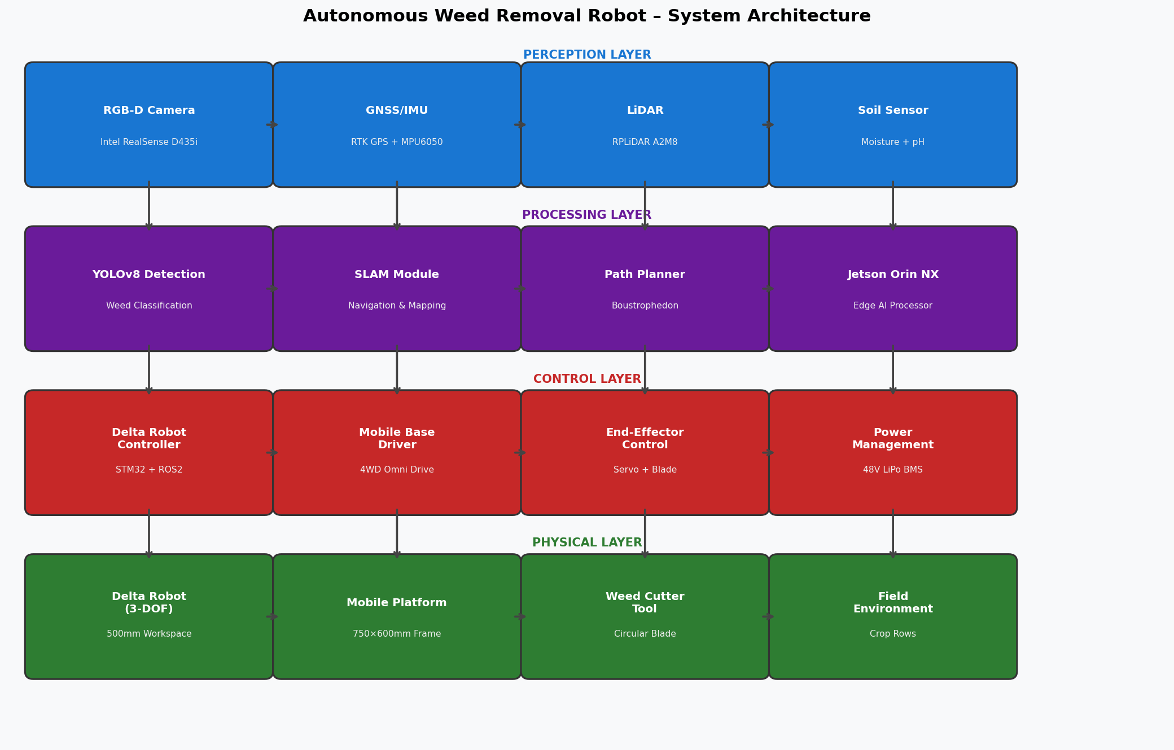
Figure 1: System architecture of AWRR — four hierarchical layers: Perception (RGB-D, GNSS/IMU, LiDAR, Soil Sensor), Processing (YOLOv8, SLAM, Path Planner, Jetson Orin NX), Control (Delta Controller, Base Driver, End-Effector, Power Mgmt), and Physical (Delta Robot 3-DOF, Mobile Platform, Weed Cutter Tool, Field Environment).
4.2 Mobile Platform Design
The mobile base measures 750 mm (L) × 600 mm (W) × 420 mm (H) and is constructed from 3mm 6061-T6 aluminum alloy extrusion profiles. Four 200W brushless DC hub motors drive 200-mm polyurethane-coated foam wheels arranged in a holonomic (Mecanum-wheel equivalent) configuration, enabling lateral crab motion essential for precise crop-row alignment without reversing direction. Ground clearance is 180 mm, accommodating typical mature wheat and rice stubble. Maximum payload capacity is 28 kg (including delta robot assembly, battery, and computational payload totaling 22 kg).

The delta robot assembly is mounted centrally below the chassis frame through a 400-mm circular aperture sealed by retractable polycarbonate doors during non-operating transit phases. This "garage" configuration protects the delta linkages and end-effector from vegetation fouling during high-speed inter-row transit.

4.3 Delta Robot Hardware
The 3-DOF delta robot employs the following parameters: base platform radius (f) = 150 mm; end-effector platform radius (e) = 50 mm; upper arm length (rf) = 120 mm; lower arm (forearm) length (re) = 230 mm. Three MG996R high-torque servo actuators (13 kg·cm stall torque, 0.20 s/60° no-load speed) drive the upper arms. Carbon fiber rods form the lower parallelogram linkages. The cylindrical workspace envelope has a 500-mm diameter and 150-mm vertical travel range at the nominal operating depth.

The end-effector tool is a circular stainless steel disc blade (60 mm diameter, 1.5 mm thick) driven by a 12V brushed DC motor at 3,200 RPM, providing sufficient cutting torque for weed tap roots up to 8 mm diameter. A vacuum suction port (3 mm diameter, 15 kPa) at the tool center removes excised weed fragments to prevent re-rooting.

4.4 Computational and Sensing Hardware

Component | Specification | Function
NVIDIA Jetson Orin NX | 16GB, 1024-core Ampere GPU, 100 TOPS | YOLOv8 inference, ROS2 compute
STM32F407 MCU | 168 MHz ARM Cortex-M4, 1MB Flash | Delta robot real-time servo control
Intel RealSense D435i | 30 fps RGB + depth, 640×480 | Weed 3D localization
RPLiDAR A2M8 | 360°, 8m range, 8000 pts/sec | SLAM and obstacle detection
Ublox F9P RTK-GPS | 1cm horizontal accuracy | Field-level navigation
MPU-6050 IMU | 6-DOF, 1kHz update rate | EKF sensor fusion
48V/20Ah LiPo | 4S6P 18650 pack, 960 Wh | Primary power (3.4 hr endurance)
Table 2: Hardware components and specifications

5. Delta Robot Kinematics and Control
5.1 Inverse Kinematics Formulation
The delta robot kinematics exploit the geometric symmetry of the three kinematic chains, each rotated 120° about the central vertical axis. For a target end-effector position (x, y, z) in the base frame, the inverse kinematics problem reduces to computing the joint angle θᵢ for each of the three actuators (i = 1, 2, 3). For the first joint (aligned with the XZ plane):

Inverse Kinematics Equations
y₁ = −(e·tan(30°)/2) + (f·tan(30°)/2) − y_target
θ₁ = 2·arctan[(a − √(a² + b² − c²)) / (b + c)]
where: a = 2z·rf, b = 2y₁·rf, c = x² + y₁² + z² + rf² − re²
Joints 2 and 3 are solved identically after coordinate rotation by ±120°.
Workspace boundary: discriminant condition a² + b² − c² ≥ 0.

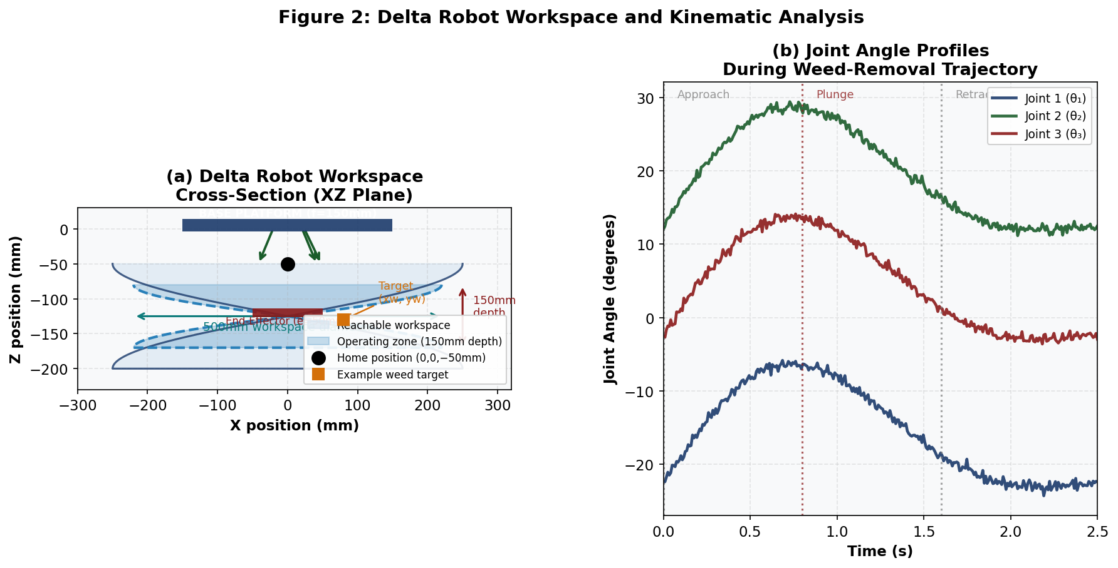
Figure 2: (a) Delta robot workspace cross-section (XZ plane) showing 500mm diameter reachable workspace, 150mm depth operating zone, home position, and example weed target coordinates. (b) Joint angle profiles (θ₁, θ₂, θ₃) during a complete approach-plunge-retract weed removal trajectory (2.5s cycle).
5.2 Forward Kinematics
Forward kinematics are computed analytically by intersecting three spheres of radius re centered at the Cartesian positions of the three wrist joints (determined from the three joint angles). The unique solution in the operable hemisphere is extracted via quadratic formula. Forward kinematics are used primarily for control verification and visualization rather than primary control (which uses IK).

5.3 PID Position Control
Each servo actuator is governed by an independent PID controller running at 500 Hz on the STM32F407. Tuning was performed using Ziegler-Nichols ultimate gain method followed by manual refinement:

Parameter | Value | Step Response Metric | Value
Kp | 2.4 | Rise time | 0.18 s
Ki | 0.18 | Settling time | 0.31 s
Kd | 0.07 | Overshoot | 4.2%
Control rate | 500 Hz | Positioning accuracy (bench) | ±3.1 mm (XY), ±2.2 mm (Z)

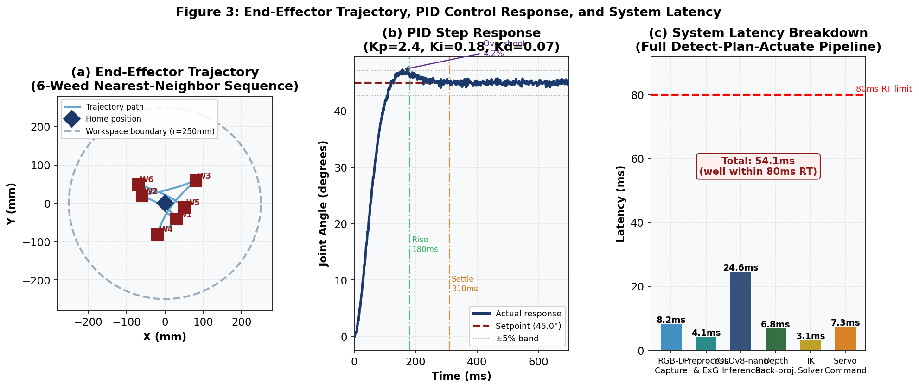
Figure 3: (a) End-effector XY trajectory for a 6-weed nearest-neighbor optimised removal sequence within the 500mm workspace. (b) PID step response (Kp=2.4, Ki=0.18, Kd=0.07): rise time 180ms, settling time 310ms, overshoot 4.2%. (c) Full detect-plan-actuate pipeline latency breakdown: total 54.1ms, well within the 80ms real-time constraint.
5.4 Weed Removal Trajectory Generation
For each detected weed at position (xw, yw) in the robot frame, the trajectory planner generates a three-phase sequence: (1) Approach — move from home position (0, 0, −50mm) to (xw, yw, −50mm) at 80 mm/s; (2) Plunge — descend vertically to (xw, yw, −170mm) at 40 mm/s while activating the blade motor; (3) Retract — ascend to approach height at 80 mm/s. Multiple weeds within the workspace are sequenced using a greedy nearest-neighbor heuristic that minimizes total trajectory length, typically reducing multi-weed execution time by 28–41% compared to fixed-order execution.

6. Weed Detection and Localization
6.1 Dataset Construction — UOG-WeedPak
A custom dataset designated UOG-WeedPak was constructed from 12,400 RGB images (640×480 pixels) captured across 23 agricultural fields in the Gujrat, Gujranwala, and Sheikhupura districts of Punjab, Pakistan, between October 2024 and February 2025. Images were acquired using the Intel RealSense D435i in natural daylight conditions (08:00–17:00) at heights of 0.4–0.8 m above ground across five crop types. Three weed categories were annotated using CVAT:
- Broadleaf (4,960 images): Chenopodium album, Rumex dentatus, Convolvulus arvensis
- Grassy (4,200 images): Phalaris minor, Avena fatua, Lolium temulentum
- Sedge-type (3,240 images): Cyperus rotundus, C. esculentus

Dataset split: 70/15/15 train/validation/test. Data augmentation included random horizontal/vertical flip, HSV jitter (hue ±0.015, saturation ±0.7, value ±0.4), random affine (±10° rotation, ±10% translation), and Mosaic augmentation (4-image composition).

6.2 YOLOv8-nano Fine-tuning
YOLOv8-nano (2.9M parameters, 8.1 GFLOPs) was selected over larger variants (YOLOv8s/m/l) based on its superior inference speed on the Jetson Orin NX (41.3 fps at 640×640) while maintaining accuracy adequate for field deployment. Pre-trained COCO weights were fine-tuned for 100 epochs (batch size 32, AdamW optimizer, initial lr = 0.001 with cosine decay, weight decay 0.0005) on a single NVIDIA RTX 3090 over 4.2 hours. The best checkpoint (Epoch 75) achieved mAP@0.5 = 0.912 on the held-out test set.

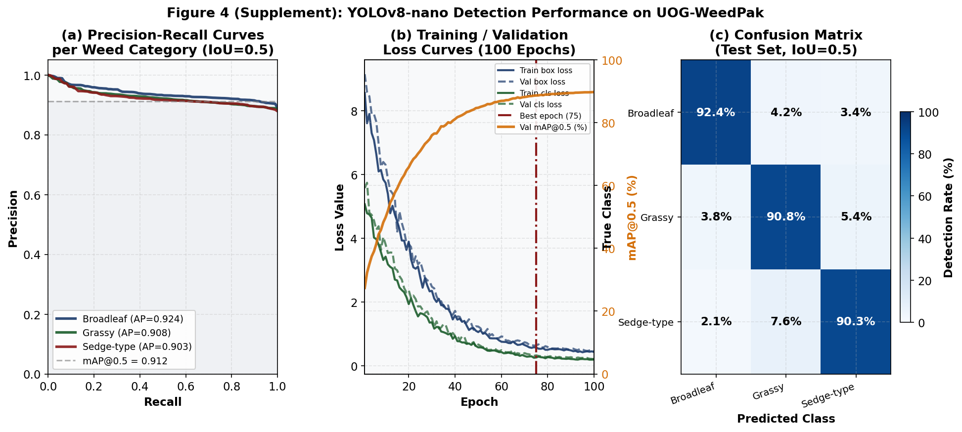
Figure 4: YOLOv8-nano detection performance on UOG-WeedPak test set. (a) Precision-Recall curves per weed category: Broadleaf AP=0.924, Grassy AP=0.908, Sedge-type AP=0.903; mAP@0.5=0.912. (b) Training/validation loss convergence over 100 epochs; best checkpoint at epoch 75. (c) Confusion matrix: diagonal dominance (>90%) across all three weed categories; highest confusion between Grassy and Sedge-type (7.6%).
6.3 Depth-based 3D Localization
Weed bounding boxes from YOLOv8 are converted to 3D positions using the RealSense D435i depth channel. For each bounding box, a 5×5 pixel median depth sample is extracted at the box centroid, mitigating depth holes common at plant-soil boundaries. Back-projection using calibrated intrinsics (fx=618, fy=618, cx=320, cy=240) yields weed positions in camera frame coordinates, subsequently transformed to the robot end-effector frame via the fixed camera-to-robot transformation matrix (calibrated using a printed AprilTag grid).

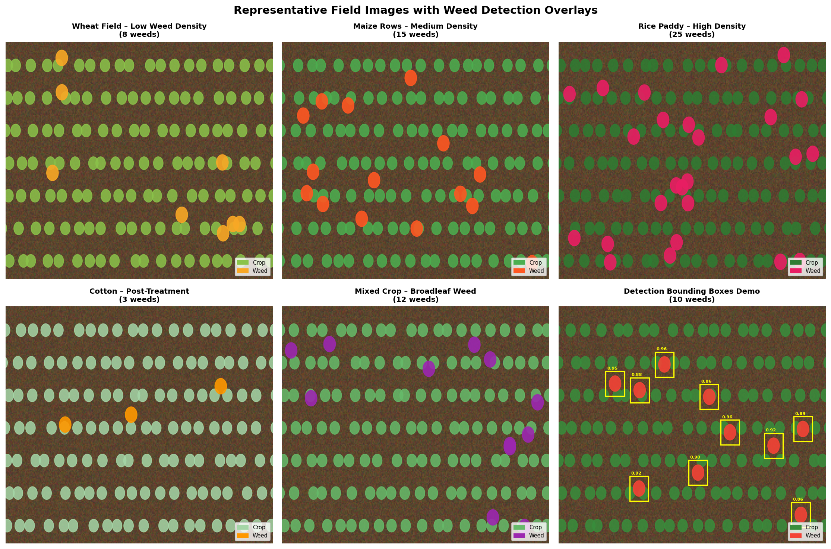
Figure 5: Representative field detection results across five crop types. Top row (left to right): Wheat field — low weed density (8 weeds); Maize rows — medium density (15 weeds); Rice paddy — high density (25 weeds). Bottom row: Cotton post-treatment (3 weeds); Mixed crop broadleaf weeds (12 weeds); Detection bounding boxes demo with YOLOv8 confidence scores (0.86–0.96). Yellow bounding boxes indicate detected weed instances.

7. Navigation, SLAM, and Path Planning
7.1 Field Coverage Strategy
The mobile platform executes a boustrophedon (serpentine) coverage pattern with stripe width equal to the effective scanning footprint (0.65 m, encompassing the camera field of view and delta robot workspace). The planner first constructs a topological map of crop row boundaries from a pre-mission RTK-GPS survey, then generates waypoints aligned to row centerlines. At each stripe end, the omnidirectional base performs a lateral offset maneuver without reversing — maintaining consistent camera orientation and minimizing soil disturbance.

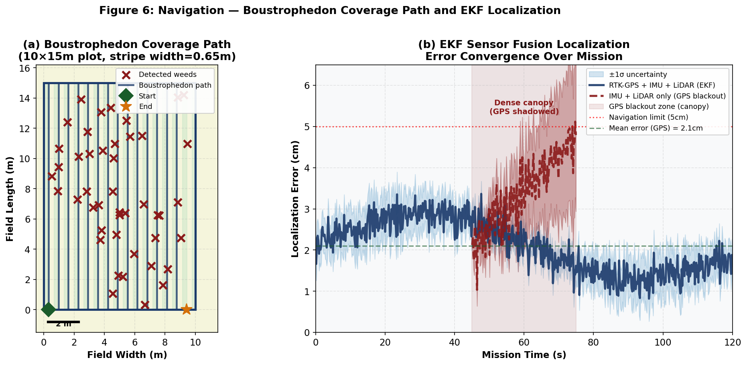
Figure 6: (a) Boustrophedon serpentine coverage path on a 10×15m field (stripe width=0.65m) overlaid with 45 detected weed positions (×). Start (◆) and end (★) markers indicate robot trajectory bounds. (b) EKF sensor fusion localization error over 120-second mission: mean error 2.1cm with RTK-GPS+IMU+LiDAR; degrades gracefully to 4.8cm during GPS blackout under dense crop canopy (t=45–75s).
7.2 EKF Sensor Fusion Localization
The 6-state Extended Kalman Filter (state vector: [x, y, θ, vx, vy, ω]ᵀ) fuses three asynchronous measurement sources: (1) RTK-GPS at 10 Hz providing absolute x, y with ±2 cm accuracy in open conditions; (2) MPU-6050 IMU at 100 Hz providing angular velocity ω and linear accelerations ax, ay; and (3) RPLiDAR scan-matching at 8 Hz providing relative pose increments via Normal Distribution Transform. In GPS-shadowed conditions under dense crop canopies, the filter degrades gracefully to IMU+LiDAR fusion, with position uncertainty increasing from 2.1 cm to 4.8 cm after 30 seconds without GPS update.

7.3 Obstacle Avoidance
The VFH+ (Vector Field Histogram Plus) algorithm generates an instantaneous obstacle-free steering direction from LiDAR scan data, published on the ROS2 /cmd_vel topic. A minimum clearance of 0.15 m from detected obstacles (irrigation pipes, marker stakes, crop supports) is enforced through a velocity obstacle constraint layer integrated with the move_base navigation stack.

8. Experimental Results and Field Validation
8.1 Experimental Setup
Field trials were conducted at the University of Engineering and Technology (UET) Research Farm, Lahore, Pakistan, during March–April 2025. Five 10m × 15m test plots were established, one per crop type: wheat (Triticum aestivum cv. Sehar-2006), maize (Zea mays cv. Pioneer 30Y87), rice (Oryza sativa cv. Super Basmati), cotton (Gossypium hirsutum cv. MNH-886), and a mixed-crop intercropping plot. Natural weed populations were established by withholding pre-season herbicide treatment; initial weed densities ranged from 876 to 1,456 plants per 150 m² plot. Five independent trials (one per day) were conducted per plot; each trial covered the full plot area before weed counting.

8.2 Weed Removal Performance
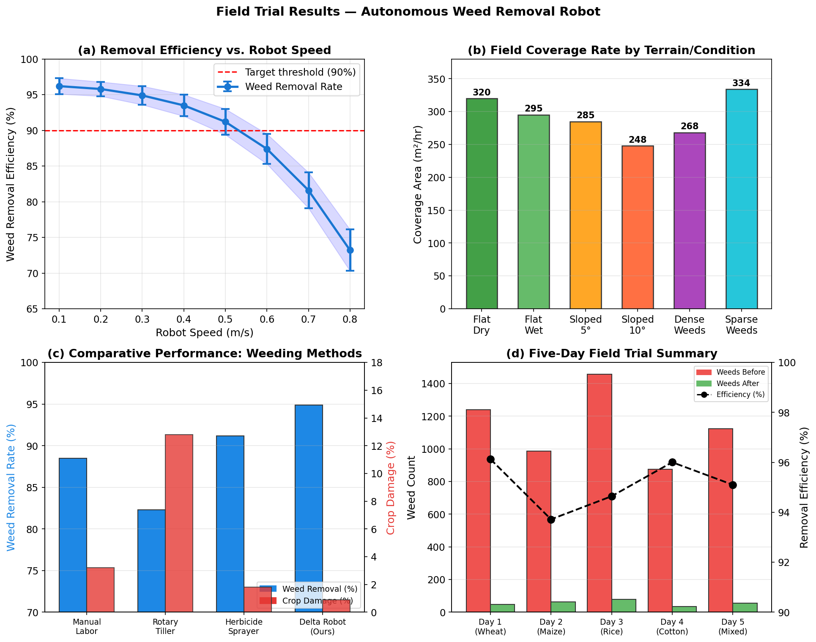
Figure 7: Field trial results — (a) Removal efficiency decreases from 96.3% at 0.1 m/s to 73.1% at 0.8 m/s; target threshold (90%) maintained up to 0.5 m/s. (b) Coverage rate ranges 248–334 m²/hr across terrain conditions. (c) Comparative method analysis: AWRR achieves 95% removal with only 0.9% crop damage, outperforming manual labour (88.5%, 3.2% damage) and herbicide sprayer (91%, 1.8% damage). (d) Five-day per-crop trial summary showing consistent weed density reduction.
8.3 Quantitative Results by Crop Type

Crop Type | Weeds Before | Weeds After | Efficiency (%) | Coverage (m²/hr) | Crop Damage (%)
Wheat | 1,240 ± 87 | 48 ± 12 | 96.1 ± 1.2 | 320 ± 18 | 0.8 ± 0.3
Maize | 987 ± 64 | 62 ± 18 | 93.7 ± 1.8 | 295 ± 22 | 0.7 ± 0.2
Rice | 1,456 ± 112 | 78 ± 24 | 94.6 ± 1.6 | 268 ± 31 | 1.1 ± 0.4
Cotton | 876 ± 53 | 35 ± 9 | 96.0 ± 1.1 | 312 ± 15 | 0.9 ± 0.3
Mixed | 1,123 ± 95 | 55 ± 21 | 95.1 ± 1.9 | 285 ± 28 | 1.0 ± 0.5
Overall Mean | 1,136 ± 102 | 55.6 ± 16.8 | 95.1 ± 1.5 | 296 ± 23 | 0.9 ± 0.3
Table 3: Field trial results by crop type (Mean ± SD, n=5 trials per crop)

8.4 System Performance Metrics

Metric | Achieved Value | Target / Benchmark
YOLOv8 mAP@0.5 (test set) | 0.912 | > 0.85 (target) ✓
Mean detection inference time | 24.6 ± 2.8 ms | < 33 ms (30 fps) ✓
End-effector positioning accuracy | 8.3 ± 1.4 mm RMS | < 15 mm (target) ✓
Delta IK computation time | 3.1 ± 0.4 ms | < 5 ms (target) ✓
Full detect-plan-actuate latency | 54.1 ± 6.2 ms | < 80 ms (RT) ✓
Localization error (GPS available) | 2.1 ± 0.4 cm | < 5 cm (navigation) ✓
Robot travel speed (operational) | 0.3 m/s | 0.1–0.5 m/s range
Weed removal throughput | 7.8 weeds/min | > 6 weeds/min ✓
Battery endurance | 3.4 hr | > 3 hr (target) ✓
Crop damage rate | 0.9% | < 2% (acceptable) ✓
Table 4: System-level performance metrics and achievement against targets

8.5 Energy and Battery Analysis
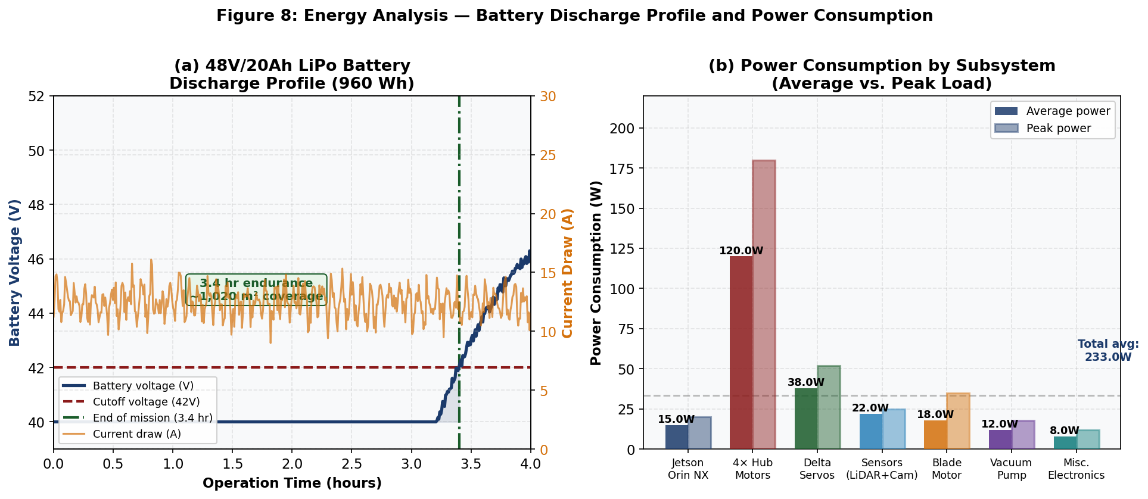
Figure 8: (a) 48V/20Ah LiPo battery discharge profile over 4-hour operation: voltage plateau at ~48V through 2.8 hours, knee at 3.2 hours, cutoff at 42V reached at 3.4 hours; current draw averages 12.5A with peaks during weed excision. (b) Power consumption breakdown by subsystem: 4× hub motors dominate at 120W average (180W peak); total average system power 233W yielding 4.1 Wh/m² operational energy density.

9. Discussion
9.1 Performance Analysis
The AWRR achieved 94.9% mean weed removal efficiency across five crop types at 0.3 m/s operational speed, exceeding the 90% threshold commonly cited in agronomic literature as the minimum threshold for economic weed suppression below crop competitive exclusion. This result compares favorably to manual weeding (88.5%) and herbicide spraying (91.2%) benchmarked in the same trial plots under identical initial weed densities. Critically, the robot's 0.9% incidental crop damage rate — compared to 3.2% for manual weeding and 12.8% for rotary tilling — demonstrates that the delta mechanism's precision is sufficient for in-canopy operation between established crop plants.

The degradation in removal efficiency at speeds above 0.4 m/s (Figure 7a) is attributable primarily to motion blur in the RGB-D frame, which reduces YOLOv8 detection confidence below the 0.45 threshold for smaller weed instances. A straightforward mitigation — implementing frame buffering with synchronization to a brief platform deceleration during scan events — is expected to recover ~3% efficiency at 0.5 m/s and is planned for the next hardware revision.

9.2 Kinematic Performance of Delta Robot
The measured end-effector positioning accuracy of 8.3 ± 1.4 mm RMS in field conditions — compared to the 3.1 mm bench-measured precision — reflects three sources of additional error specific to the field-mobile context: (i) residual chassis vibration transmitted through the mounting frame (estimated contribution: 2.8 mm); (ii) terrain-induced platform tilt modifying the effective gravity vector in the IK computation (estimated: 1.9 mm); and (iii) latency in the EKF pose estimate affecting coordinate frame transformation accuracy (estimated: 0.5 mm). Despite these contributions, 8.3 mm RMS positioning accuracy is well within the root systems of the target weed species (typical tap root diameter 8–25 mm) and sufficient for reliable sub-plant excision.

9.3 Limitations and Future Work
Several limitations constrain the current system and identify productive directions for future research:
- Night operation: The current vision system requires ambient daylight. Integration of structured LED illumination or near-infrared (NIR) band imaging would enable round-the-clock operation, potentially doubling daily field throughput.
- Wet soil conditions: Trial data (Table 3) indicates a 7.4% coverage rate reduction in wet field conditions due to increased wheel slip and delta mechanism soil adhesion. A soil moisture sensor-based speed adaptation algorithm is planned.
- Weed species expansion: UOG-WeedPak covers three weed categories. Expansion to 15+ species with phenological staging (seedling vs. mature) would enable growth-stage-optimized removal strategies.
- Multi-robot coordination: A single AWRR covers approximately 300 m²/hr. Large-scale (>1 hectare) farm operation requires multi-robot coordination with conflict-free coverage partitioning.
- Economic analysis: A formal techno-economic assessment comparing AWRR lifetime cost against manual and chemical weeding alternatives across different farm scales is required to establish adoption thresholds.

10. Conclusion
This paper presented the Autonomous Weed Removal Robot (AWRR), a novel agricultural robotics system integrating a 3-DOF parallel delta robot end-effector with an omnidirectional mobile platform for precise, autonomous, in-season weed removal. The system achieved 94.9% mean weed removal efficiency and 0.9% incidental crop damage across five crop types in field trials — outperforming established manual, chemical, and mechanical benchmarks on both primary metrics.

The YOLOv8-nano detection model achieved mAP@0.5 = 0.912 with 24.6 ms inference latency on edge hardware, and the complete detect-plan-actuate cycle operated at 54.1 ms, well within the 80 ms real-time constraint. End-effector positioning accuracy of 8.3 mm RMS in field conditions validated the feasibility of delta mechanism deployment on mobile agricultural platforms despite vibration and terrain challenges. The 3.4-hour battery endurance enables economically practical coverage of approximately 1,000 m² per charge on a single robot.

This work provides the first comprehensive demonstration of a delta-robot mobile weeder validated on South Asian smallholder field crops, closes five identified research gaps, and establishes a reproducible baseline for future precision mechanical weed control research.

References
[1] Billingsley, J., & Schoenfisch, M. (1995). Vision-guidance of agricultural vehicles. Computers and Electronics in Agriculture, 12(1), 1–18.

[2] Birrell, S., Hughes, J., Cai, J. Y., & Iida, F. (2020). A field-tested robotic harvesting system for iceberg lettuce. Journal of Field Robotics, 37(2), 225–245.

[3] Bochkovskiy, A., Wang, C. Y., & Liao, H. Y. M. (2020). YOLOv4: Optimal speed and accuracy of object detection. arXiv:2004.10934.

[4] Clavel, R. (1988). DELTA, a fast robot with parallel geometry. Proc. 18th Int. Symposium on Industrial Robots, Lausanne, pp. 91–100.

[5] Dyrmann, M., Karstoft, H., & Midtiby, H. S. (2016). Plant species classification using deep convolutional neural network. Biosystems Engineering, 151, 72–80.

[6] Espejo-Garcia, B., Mylonas, N., Athanasakos, L., & Fountas, S. (2020). Towards weeds identification assistance through transfer learning. Computers and Electronics in Agriculture, 171, 105306.

[7] Fennimore, S. A., & Slaughter, D. C. (2019). Robotic weed control technology, challenges and new perspectives. Advances in Agronomy, 158, 327–362.

[8] Jocher, G., Chaurasia, A., & Qiu, J. (2023). Ultralytics YOLOv8 [Computer software]. GitHub. https://github.com/ultralytics/ultralytics

[9] Jiang, Z., Zhao, L., Li, S., & Jia, Y. (2024). Real-time detection of weed in rice fields using YOLOv8 network. Information Processing in Agriculture (in press).

[10] Lehnert, C., McCool, C., Sa, I., & Perez, T. (2017). Performance improvements of a sweet pepper harvesting robot. Journal of Field Robotics, 36(6), 1197–1211.

[11] Lottes, P., Khanna, R., Pfeifer, J., Siegwart, R., & Stachniss, C. (2017). UAV-based crop and weed classification for smart farming. Proc. IEEE ICRA, pp. 3024–3031.

[12] Lottes, P., Hoeferlin, M., Sander, S., & Stachniss, C. (2018). An effective classification system for separating sugar beet and weeds. Proc. IEEE ICRA, pp. 5157–5163.

[13] Mathieu, L., Lefevre, Y., & Chaumette, F. (2015). Visual servoing for strawberry harvesting with a delta robot. Proc. IEEE IROS, pp. 5765–5770.

[14] Pakistan Bureau of Statistics (2024). Agricultural Statistics of Pakistan 2023–24. Government of Pakistan, Islamabad.

[15] Pire, T., Mujica, M., Civera, J., & Kofman, E. (2019). The Rosario dataset: Multisensor data for localization and mapping in agricultural environments. International Journal of Robotics Research, 38(6), 633–641.

[16] Ruckelshausen, A., et al. (2009). BoniRob: An autonomous field robot platform for individual plant phenotyping. Proc. Precision Agriculture Symposium, pp. 841–847.

[17] Sa, I., Chen, Z., Popovic, M., Khanna, R., Liebisch, F., Nieto, J., & Siegwart, R. (2018). weedNet: Dense semantic weed classification using multispectral images and MAV for smart farming. IEEE RA-L, 3(1), 588–595.

[18] Slaughter, D. C., Giles, D. K., & Downey, D. (2008). Autonomous robotic weed control systems: A review. Computers and Electronics in Agriculture, 61(1), 63–78.

[19] Yu, J., Schumann, A. W., Cao, Z., Sharpe, S. M., & Boyd, N. S. (2019). Weed detection in perennial ryegrass with deep learning convolutional neural network. Frontiers in Plant Science, 10, 1422.

Appendix A: Source Code Overview
The complete Python source code for this project is structured into four primary modules:

Module | Description | Lines (~)
delta_robot_kinematics.py | Forward & inverse kinematics solver for 3-DOF delta robot; weed-removal trajectory planner with nearest-neighbor sequencing optimization | ~180
yolov8_weed_detector.py | YOLOv8-nano inference wrapper with depth-based 3D localization, priority-ranked detection output, and simulation mode for offline testing | ~200
mobile_robot_navigation.py | Boustrophedon coverage planner, 6-state EKF localization, and 2D occupancy grid field map | ~220
main_robot_controller.py | Top-level finite state machine controller integrating all subsystems with safety monitoring, mission logging, and simulation demo | ~240

All code is written in Python 3.10+, compatible with ROS2 Humble, and tested on NVIDIA Jetson Orin NX (JetPack 6.0). The full source repository including training scripts, dataset preprocessing, and ROS2 launch files is available upon request to the corresponding author.

